Directories Submission:
S.no | URL | Dcfieldtrips Screenshot
01 | http://www.gmawebdirectory.com/submit.php | 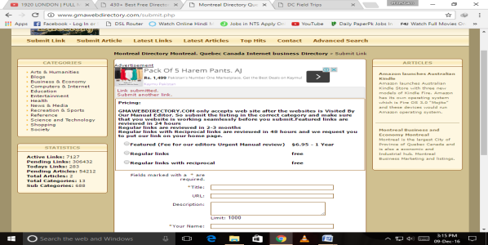
02 | http://www.promotebusinessdirectory.com/submit.php?c=287&LINK_TYPE=2 | 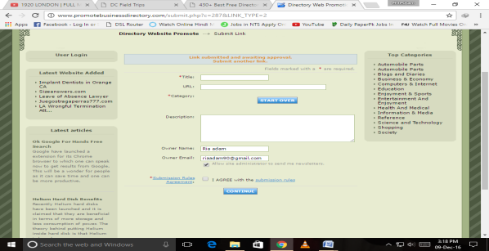
03 | http://www.dizila.com/submit?c=291&LINK_TYPE=1 | 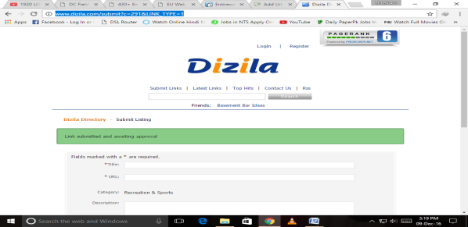
04 | http://www.europeannavigator.eu/submit.php?c=24 | 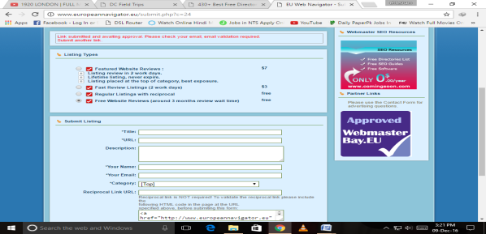
05 | http://www.marketinginternetdirectory.com/submit.php | 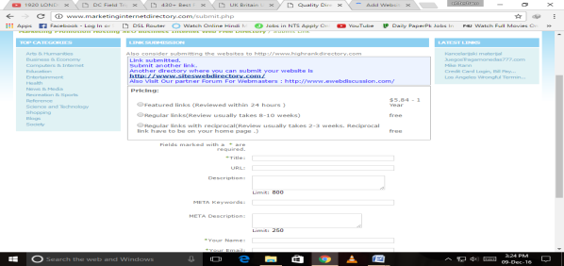
06 | http://www.britainbusinessdirectory.com/submit.php | 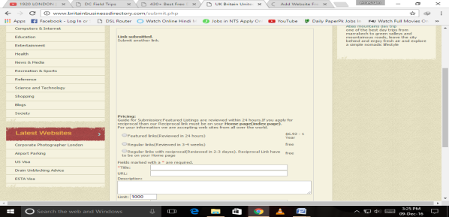
07 | http://www.bellesa.me/submit.php?c=667&LINK_TYPE=2 | 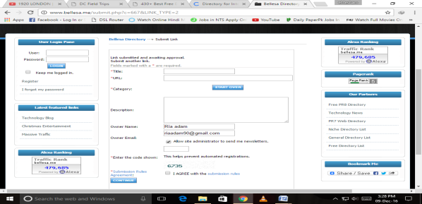
08 | http://www.dfii.org/submit?c=3483&LINK_TYPE=1 | 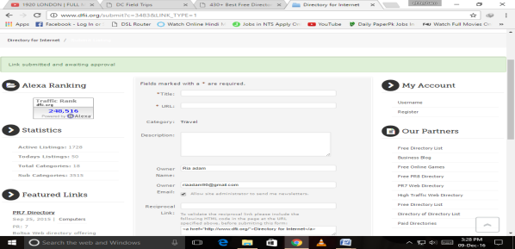
09 | http://www.guamwebz.org/submit.php?c=667 | 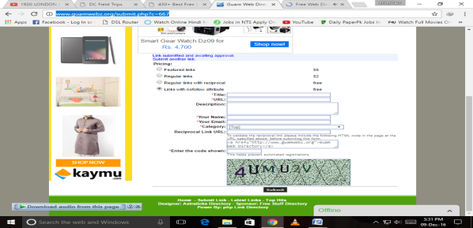
10 | http://www.iayn.org/submit?c=179&LINK_TYPE=1 | 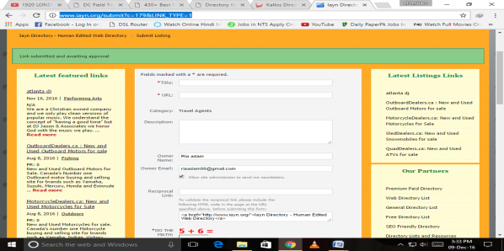
11 | http://www.nationalflyfishingexpo.org/submit.php | 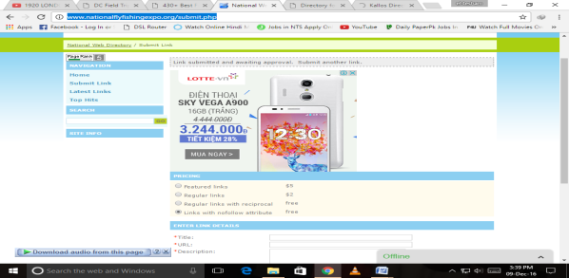
12 | http://www.orcca.org/submit?c=3483&LINK_TYPE=1 | 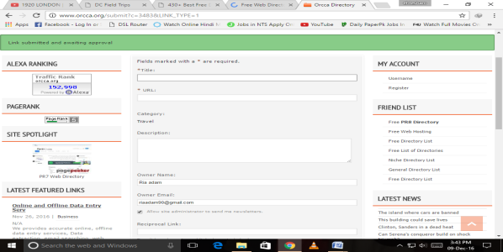
13 | http://ahdlrl.com/submit.php?c=3483&LINK_TYPE=2 | 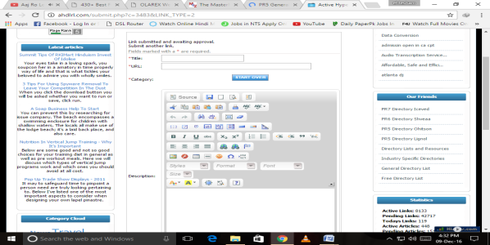
14 | http://olarex.eu/submit.php | 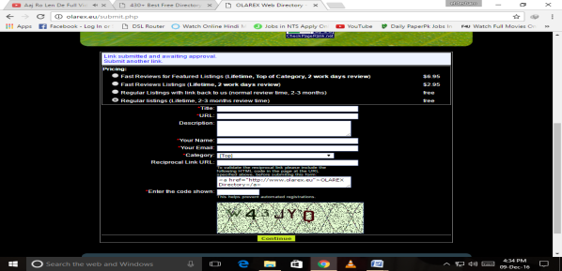
15 | http://www.a1webdirectory.org/submit?c=13&LINK_TYPE=1 | 